
400

SiRFprima
Video Renderer SDK (for WinCE)

October 2008
Document Number: CSM-00400
Revision D

Table of Contents
Introduction 1
Set Up Environment 1
Build Environment 1
Operating Environment 1
Functions 1
Sample Code Package 2
General Comments 4
Call Sequence When Using SiRFprima Video Renderer SDK 5

List of Tables
Table 1: SDK Functions 2

List of Figures
Figure 1: Call Sequence 5

Introduction
This document provides a guideline for using the Software Development Kit (SDK) for the SiRFprima™ Video Renderer including sample code.
This document only applies to the WinCE platform.

Set Up Environment
Build Environment
To use the SiRFprima video renderer while building, the following files must be included in the project:
- RendererSDK.h
Declares all Renderer SDK APIs.
- Platform.h
Contains the type definition for multi-platforms.
- BHVidRenderer.lib
The import library for building.
Operating Environment
In order to run the application on the SiRFprima video renderer, the following library should be copied into the \windows folder:
- BHVidRenderer.dll

Functions
The table below lists all functions of the SiRFprima video renderer SDK. For more details, please refer to the RendererSDK.h file and CSM-00399: SiRFprima Video Renderer SDK V1 API User Guide. The following APIs are declared in RendererSDK.h and can be imported from BHVidRenderer.lib.
Function Name | Purpose
CVR_CreateVideoRender | Create a video renderer handler.
CVR_DeleteVideoRender | Delete the video renderer handler.
CVR_SetVideoFormat | Set source video information.
CVR_SetDisplayMode | Set display mode for the target screen.
CVR_SetDstRect | Set destination video rectangle.
CVR_Render | Render a video frame.
CVR_WaitComplete | Wait until the rendered video finishes.
CVR_CreateSurface | Create a surface (frame buffer) for rendering.
CVR_DestroySurface | Destroy a surface created by CVR_CreateSurface.
CVR_LockSurface | Lock the surface so that the caller can access the internal frame buffer directly.
CVR_UnlockSurface | Unlock the specified surface.
CVR_SetOSDRegionNum | Set the number of OSD regions you want to paint on screen.
CVR_SetOSDInfo | Set configuration information for on-screen display bitmap.
CVR_EscapeCtrl | Set/get special parameters for the video renderer.
CVR_GetLastError | Get the internal error code from the last operation, which is platform dependent and is provided as a way to diagnose renderer malfunctions.
CVR_SetDeinterlaceMode | Set the de-interlace mode for rendering.
CVR_SetRenderLayer | Set the layer on which the video will be put on.

Table 1: SDK Functions

Sample Code Package
The following code demonstrates a typical usage of the SiRFprima video renderer SDK.
#include "RendererSDK.h"
int main(int argc, char *argv[])
{
//Video Renderer handle
VR_HANDLE hRenderer;
//Create Video Renderer handle
//hWnd: handle of parent window.
CVR_CreateVideoRender(&hRenderer, hWnd);
//[optional] it will change settings in renderer.
//TITAN_BITMAP_ORDER: this is the set the bitmap data order //inputted.
//pInBuf: the pointer of input data block
//data_size: the size of input data block
//pOutBuf: the pointer of output data block.
CVR_EscapeCtrl(hRenderer, TITAN_BITMAP_ORDER, pInBuf, data_size, pOutBuf);
//[optional] it sets the layer video will be put on
//layer: the layer video will be put on, it is recommended to be overaly surface.
//fAlpha: the alpha blending value of video rendering, only
// available for overlay layer
CVR_SetRenderLayer(hRenderer, layer, fAlpha);
//[optional] it will set the display mode
//mode: the display mode to be set， it should be initialized at first, and the rendering mode is recommended to be VR_REN_FULL
CVR_SetDisplayMode(hRenderer, mode);
//Set the Video parameters.
//VR_FORMAT_I420: set the input data format as I420
//width: width of source frame
//height: height of source frame
//rect: the source rect
//LumPitch: pitch of lum
//ChromPitch: pitch of chrom
CVR_SetVideoFormat(hRenderer, VR_FORMAT_I420, width, height, &rect, &LumPitch, &ChromPitch);
//[optional]Set deinterlace mode for render
//VR_DEINTERLACE_FIELD_ODD: only odd field is rendered.
CVR_SetDeinterlaceMode(hRenderer, VR_DEINTERLACE_FIELD_ODD);
VR_FRAME_SURFACE* pSurf;
//pSurf: the pointer of surface to be created.
//bPhysical: it indicates physical memory is forced to be returned.
CVR_CreateSurface(hRenderer, &pSurf, bPhysical);
//[optional] it sets the destinate rectangle
//rect: the destinate rectange on screen.
CVR_SetDstRect(hRenderer, rect);
if(OSD)
{
//it sets the max number of OSDs those will be used.
//num: the max number of OSDs those will be used.
CVR_SetOSDRegionNum(hRenderer, num);
//it input the OSD information into renderer.
//region_num: the number of OSDs those will be inputted this //time.
//info: the array of OSDs those will be inputted this time.
CVR_SetOSDInfo(hRenderer, region_num, info);
}
//playing
while(NOT_END)
{
//Lock the surface
//pSurf: surface to be locked.
CVR_LockSurface(hRenderer, pSurf);
//copy data into pSurf
WRITE_TO_SURFACE();
//Unlock the surface
//pSurf: surface to be unlocked.
CVR_UnlockSurface(hRenderer, pSurf);
//Render the data wrotten at last.
//pSurf: the surface to be rendered.
//VR_SYNC_WAITVSYNC: this render will blt video on vertical
blank.
CVR_Render(hRenderer, pSurf, VR_SYNC_WAITVSYNC);
//[not implemented] wait for finishing of rendering
CVR_WaitComplete(hRenderer);
}
//Rlease the allocated surface
//pSurf: the surface to be destoried.
CVR_DestroySurface(hRenderer, pSurf);
//Release the handle of video renderer.
CVR_DeleteVideoRender(hRenderer);
}

General Comments
- This SDK release does not support thread-safe.

- The number of surfaces that can be created depends on the available memory space.

- It is necessary to free the OSD bitmap bits buffer once the OSD is set. Do not keep the buffer until the OSD is cleared.

- The OS image does not need to be updated in later SDK releases unless it is specified in the release notes.

Call Sequence When Using SiRFprima Video Renderer SDK
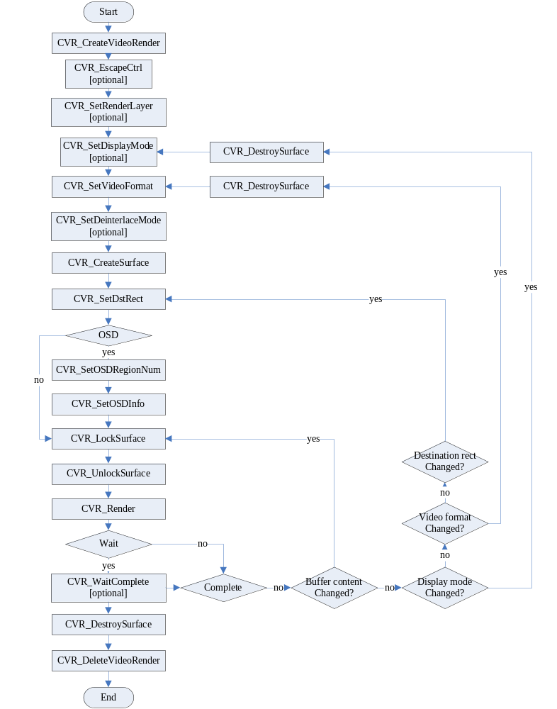

Figure 1: Call Sequence



© 2008 SiRF Technology, Inc.

This document contains proprietary information to SiRF Technology, Inc. and shall not be reproduced or transferred to other documents or disclosed to others or used for any purpose other than that for which it was obtained without expressed written consent of SiRF Technology, Inc.

All other products or company names mentioned herein are used for identification purposes only, and may be trademarks of registered trademarks of their respective owners.

SiRF Technology, Inc. reserves the right to make changes in its products, specifications and other information at any time without notice. SiRF assumes no liability or responsibility for any claims or damages arising out of the use of this document, or from the use of integrated circuits based on this document, including, but not limited to claims or damages based on infringement of patents, copyrights or other intellectual property rights. SiRF makes no warranties, either express or implied with respect to the information and specifications contained in this document. Performance characteristics listed in this data sheet do not constitute a warranty or guarantee of product performance. All terms and conditions of sale are governed by the SiRF Terms and Conditions of Sale, a copy of which you may obtain from your authorized SiRF sales representative.

